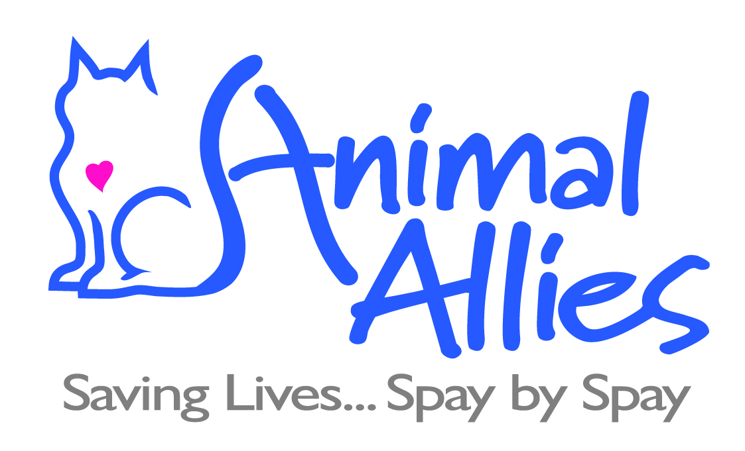
PO Box 693, Manchester, NH 03105 (603) 228-6755, animalallies.org

Here are the instructions for having your cat spayed/neutered through Animal Allies.

You agreed to pay for the surgery and you must pay that morning. Females cost $160.00 and males cost $110.00. The law requires that all cats that are at least 12 weeks old must be vaccinated against rabies. If your cat is old enough and hasn’t received the vaccination, you must pay $30.00 for the vaccine to be administered. If you want your cat to also have the distemper vaccine, it will cost an additional $30.00. If there is any chance your cat has fleas, we recommend you have him/her treated several days ahead of time or plan to pay an additional $30.00 for the flea treatment that the vet will administer. It is a policy of the animal hospital that any pet entering the building with fleas automatically gets treated and the charge is $30.00. We will collect this from you at pick-up if the receipt shows your cat had fleas.

Because we have received so many bad ones, we can no longer accept personal checks. From now on, we will accept ONLY CASH OR MONEY ORDERS. If you pay with cash, please bring exact change, if possible. If you pay by money order, make it payable to Animal Allies. No credit or debit cards, please.

1. You MUST drop off your cat at 7:00 am on the day of surgery at Kool K9, a doggy daycare, at 1109 Hooksett Road in Hooksett and meet our volunteer outside. You must be on time, because our volunteer needs to get to work on time.

2. The cat must not have any food or water after midnight the night before.

3. The cat must come in a secure crate (a cat carrier is fine) with a towel or small blanket inside. No cloth or cardboard carriers allowed! We have had cats escape from them. Please fill out the Pembroke Animal Hospital consent form ahead of time and attach it to the carrier.

4. Pick up your cat at the same location between 5:00 and 5:15 pm that same evening. DO NOT CALL the vet’s office to see if your cat can be picked up early. They are generously providing a low-cost service and extra phone calls unnecessarily take up their valuable time.

5. Call 228-6755 if you have questions or need to cancel the appointment. It’s important that you call if you are not going to be able to make the appointment. Otherwise, our volunteer will be waiting for you needlessly. Also, we might be able to get someone else’s cat done.

